Interrogative Pronouns

🔹 What Are Interrogative Pronouns?
# Source: AI Source: Provided by: [Data Path: Persons Table -> ID Column: 1, Name_En Column: Motasem Essam] -> From: [Chatgpt (GPT-4-turbo)] on [7/27/2025]
Interrogative pronouns are pronouns used to ask questions.
They stand in for the unknown person or thing that the question is about.

✅ List of Interrogative Pronouns
# Source: AI Source: Provided by: [Data Path: Persons Table -> ID Column: 1, Name_En Column: Motasem Essam] -> From: [Chatgpt (GPT-4-turbo)] on [7/27/2025]
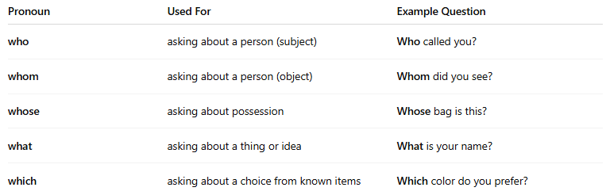
Pronoun | Used For | Example Question
who | asking about a person (subject) | Who called you?
whom | asking about a person (object) | Whom did you see?
whose | asking about possession | Whose bag is this?
what | asking about a thing or idea | What is your name?
which | asking about a choice from known items | Which color do you prefer?

📚 Examples in Sentences
# Source: AI Source: Provided by: [Data Path: Persons Table -> ID Column: 1, Name_En Column: Motasem Essam] -> From: [Chatgpt (GPT-4-turbo)] on [7/27/2025]
- Who is coming to the party?
- Whom are you waiting for?
- Whose phone is ringing?
- What do you need?
- Which of these pens is yours?

🧠 Notes:
# Source: AI Source: Provided by: [Data Path: Persons Table -> ID Column: 1, Name_En Column: Motasem Essam] -> From: [Chatgpt (GPT-4-turbo)] on [7/27/2025]
- Who vs Whom:
  - Who = subject (does the action) → Who called you?
  - Whom = object (receives the action) → Whom did you call?
- Which vs What:
  - Which = choosing from a specific group → Which dress do you like?
  - What = open question (no specific options) → What do you want to eat?

